Announcements

St. Ann Catholic Church  202 N 5th  Doniphan NE 68832  Mailing Address: PO Box 407  Office Phone: 402-845-2707  *Social Hall: 402-845-2713  (Mass & Confession Schedule Recording  for both Parishes)  email address: stanns@cdolinc.net  www.stannsdoniphan.org | Pastor:  Fr. David A. Oldham  Father’s Cell Phone:  402-801-1469  Office Hours:  Monday- Thursday  8:15 a.m.-10:15 a.m. | Sacred Heart  Catholic Church  100 W Pine Street  Kenesaw, NE 68956  Parish Mailing Address:  PO Box 407  Doniphan, NE 68832  Office: 402-845-2707  email address: stanns@cdolinc.net  www.sacredheartkenesaw.org
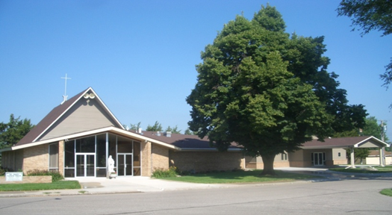
MOTHER/DAUGHTER PROGRAM “Fearfully and Wonderfully Made” for girls age 9-13 and their mothers will be held Sunday, October 30, 2022 from 2:00-4:00 pm at Lourdes High School in Nebraska City and virtually. This program is designed to educate girls on growing up and becoming a woman. Pre-registration is required. Cost is $25 per mother/daughter or $35 per family in person and $10 virtually. To register, visit https://lincolndiocese.regfox.com/motherdaughternebcity. Questions, please call Dotti Easter at 402-297-1211 or email dottieaster3@gmail.com.

FATHER/SON PROGRAM “In His Image” for boys age 10-14 and their fathers will be held Sunday, November 13th, 2022, from 2-5 p.m. at Lourdes High School. This program is designed to educate boys on growing up and becoming a man. Pre-registration is requested. Event is sponsored by the Knights of Columbus and is free to attend. To register, visit https://lincolndiocese.regfox.com/fathersonnebcity. Questions, please contact Patrick Gress at patrickgress@yahoo.com.
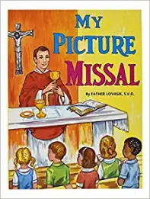
Children's Missals
To promote children's love for the Mass and ongoing education in the Catholic faith, Hastings Catholic Schools purchased children's missals for all parishes in the Hastings deanery. Please use them during Mass and keep them at the parish so others may enjoy them as well.
St. Ann’s Parish Council will meet on Monday, October 10th at 6:30pm (following 6pm Daily Mass).

There are many Pro-Life handouts on the Vestibule tables. Please help yourself!
Don’t forget to fill out and turn in your Bishop’s Appeal for Vocation Pledge Card! Thank you!
“The rich suffer want and go hungry, but those who seek the Lord lack no blessing.” Psalm 34 (33):11

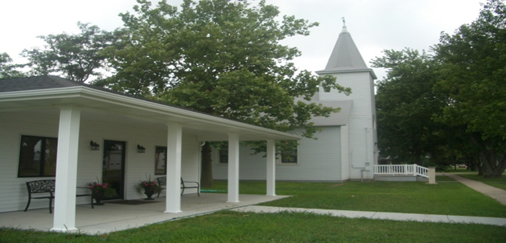
Sunday, October 9th, 2022 Twenty-Eighth Sunday in Ordinary Time

Please remember to pray for the Seminarians, Sisters, and those
in need of our prayers:
Sacred Heart Requests: Nancy Russell, Tom Meisenbach, & Isabella Eckhardt
St. Ann Requests: Richard LaBrie, Amber Schultz, & Terry Connick
Seminarian- Tyler Johnson at St. Gregory the Great from St. John’s in Lincoln.

Mass Times & Intentions
Date | Time | Parish | Mass Intention
Monday, October 10th | 6:00 pm | St. Ann | Joan Hoelting+
Tuesday, October 11th | 7:00 am | St. Ann | Bob Oldham+
Wednesday, October 12th | 7:00 am | St. Ann | All Soul’s Day Int. Fr. Phan
Thursday, October 13th | 7:00 am | St. Ann | Tom Deveny+
Friday, October 14th | 7:00 am | St. Ann | Francis & Dolores Pitz+
Saturday, October 15th | 4:00 pm | St. Ann | Bob Oldham+
Sunday, October 16th | 9:00 a.m. | St. Ann | Bernard McMahon+
Sunday, October 16th | 11:00 a.m. | Sacred Heart | Pro Populo

Confessions
St. Ann’s | Monday – Friday 20 minutes before daily Mass and every  Saturday 3:00 p.m. – 3:50 p.m.
Sacred Heart | Second Sunday of each month after Mass

Stewardship: 10/2/2022 Collection
Collection | St. Ann | Sacred Heart
Adult | $1175.00 | $426.00
Plate | $365.25 | $0.00
Children’s | $4.00 | $1.25
Maintenance | $50.00 | $0.00
Weekly Budget | $3,103.91 | $562.58
Year to Date Budget | $44,454.74 | $7,876.34
Year to Date Actual | $47,030.64 | $11,463.75
Year to Date Surplus/(Shortfall) | $2,575.90 | $3,587.41

Ministry Assignments
St. Ann | Sacred Heart
Saturday, October 15th, 2022 at 4 p.m. | Sunday, October 9th, 2022 at 11 a.m.
ACOLYTE –Mike Ley | READER / LECTOR – Matt Hurt
READER / LECTOR – Kim Finecy | ALTAR SERVERS – Kylan Parker
ALTAR SERVERS – Ben VanDiest | MUSIC- Neil Keiser
MUSICIAN/CANTOR – Acapella | OFFERTORY FAMILY- J.R. Pulver Family
********************************************************* | ********************************************************

Sunday, October 16th, 2022 at 9 a.m.
ACOLYTE – Kenny Dinan | Sunday, October 16th, 2022 at 11 a.m.
READER / LECTOR – Chuck O’Donnell | READER / LECTOR- Bonnie Engelhardt
ALTAR SERVERS – Parker Volk | ALTAR SERVERS- Leo Keiser
MUSICIAN/CANTOR – Acapella | MUSIC- Neel Keiser
ROSARY – Rob Kennedy- Glorious | OFFERTORY FAMILY- James Pulver Family

CCD/CYO
St. Ann’s CCD/CYO- Next Class- Wed., October 12th @ 7pm | Sacred Heart CCD- Wed., October 12th –  2:15pm-3:35pm
 | Sacred Heart CYO- Sun., October 30th following Mass

Announcements

The LDCCW is encouraging each Catholic to offer prayers for the upcoming elections. It is called the 50 Days for 50 States Program. There are no set prayers, just a sacrifice or prayer each day that each state can elect pro-life and pro-family representative. The states to pray for this week are Michigan, Minnesota, Mississippi, Missouri, Nebraska, Nevada

October Pro-Life Diaper Drive
Both parishes are collecting diapers for the local pregnancy centers and CSS. If you are able to donate any size diapers, it would be greatly appreciated. Please place them in the Vestibules. They will be collected and delivered. Larger sizes of diapers are in higher need (sizes 5 &6). Cash donations or checks made out to LDCCW will be accepted and should be mailed to LDCCW at 3600 W Wittstruck Road, Martell, NE 68404.

Respect Life Eucharistic Procession and Adoration, October 16
The Pro-Life Office, partnering with the Cathedral, will be hosting an outdoor Eucharistic Procession with Adoration from 3:00 to 4:00 PM on Sunday, October 16. We will process to Pioneer Park and around the neighborhood. This is a wonderful opportunity during Respect Life Month to give honor and praise to our Lord in the public setting. We pray for all our Mothers who are in Need, and for our Nation to stop the killing of babies in the womb. Thank you to Father Canela and the staff at the Cathedral for partnering with us. The four Grand Island Knights of Columbus councils will lead the procession.
Thank you!
Thank you for your support of my missionary year with Christ in the City! Your generosity helped push me over the fundraising goal, and I am grateful for your support. Be assured of my prayers for you while in Denver!
Tony Bykerk

A copy of the Prayer to St. Joseph is in the pews please join in after the rosary is said at the weekend mass. We plan to do this during the rest of October.

St. Ann’s Altar Society: We want our parish families to be aware that we have a Prayer Shawl Committee: These Prayer Shawls are gifted to members of our parish family who are experiencing life-altering events such as a severe illness/disease, death in the family etc. Prayer blankets are available for the men and children of our parish. The purpose here is to wrap the members of our parish family in the love of God and let them know that the church is praying for them in their time of need. Contact Charlene Hruby (402-984-3327) or Chris Quist (402-845-2707) with your request.

Walking with Mom’s: For those who are not aware, the USCCB has a ‘Walking With Mom’s in Need’ Program which most diocese across the country are implementing. The objective is for each parish to assist ‘Mother’s in Need’. First and foremost, is the objective that each parishioner is aware of services available in their area so they will be able to direct anyone in need to the available services. Bishop Conley and Bishop Hanefeldt are both encouraging active participation in this program.The July 8th issue of the Southern Nebraska Register has several good articles about this program and some great information to know. A bulletin insert also gives great information about the program.
Last, prayerfully consider being a committee member for this WWMIN program.
It is up to the individual parishes on how involved, what if any parish programs they want to offer, etc…Also, the committee meetings can be kept short and sporadic. Some meetings could even be held by zoom if that is what committee members want. Also, it is not necessary that the Pro-Life Co-Ordinator for the Parish (that’s me) be

the chairperson of the committee. As Pro-Life Administrator for the Diocese of Grand Island I do have access and knowledge of the program and materials but I can also just share that information with the committee. I do plan to be actively involved in the committee but if anyone
is at all interested in being chairperson PLEASE feel free to share that at the first meeting or call me at 402.984.8434. More information on date and time of first Committee Meeting forthcoming.

